# Header

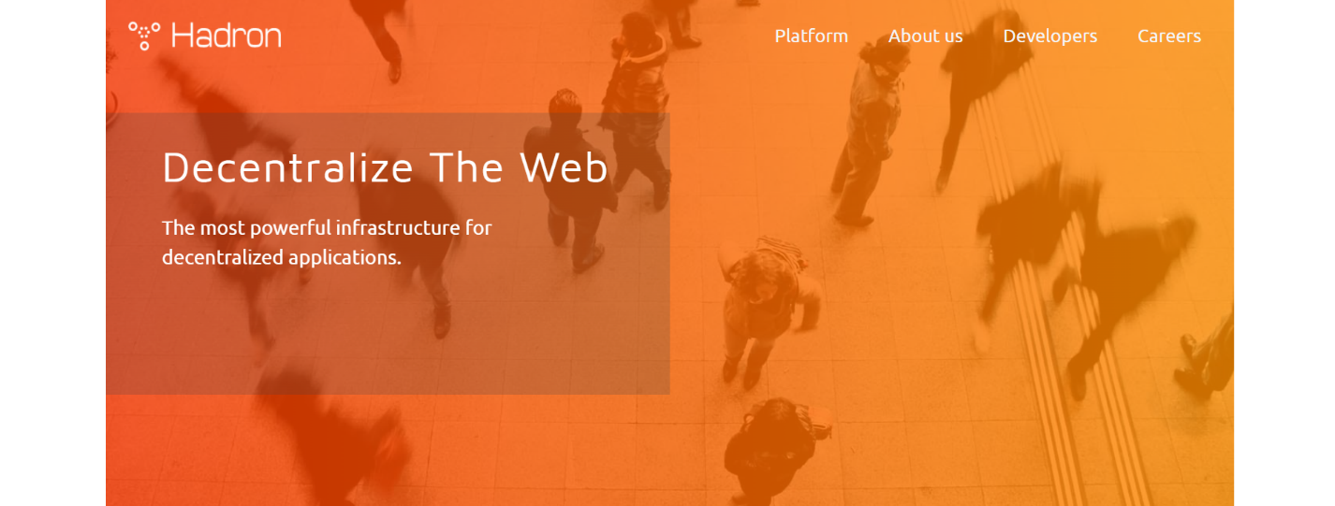

Colors: gradient - rgba(248,54,0,.8), rgba(254,140,0,.8)

Font: h1 - Maven_Pro, nav - Ubuntu

Use: header, h1, nav, ul, li, a

Hover a :

# Vision



Colors: gradient - #6c16e1

Use: section, p , h2, button

Hover button:



# Build on

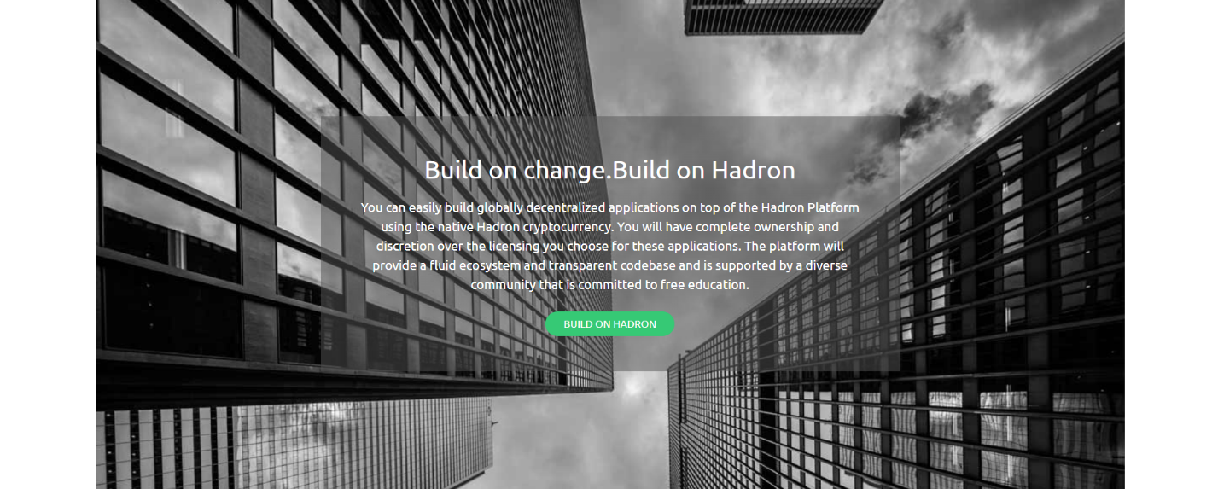

Color: rgba(83,83,83,.5), #36c975

Use: section, h2, p, button, article

Hover button:

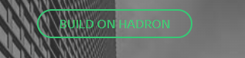

# Build

Color: #f83600

Use: section, h2, figure, img, figcaption, h4, p

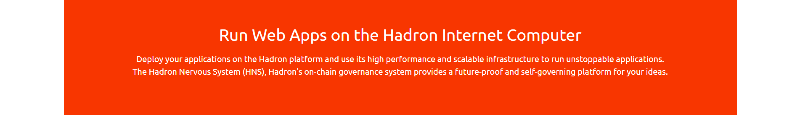

# Advantage

Color: gradients(1 - rgba(84,74,125,.8), rgba(250,200,51,.8), 2 - rgba(24,90,157,.8), rgba(67,206,162,.8), 3 - )

Use: section, h3, p, article

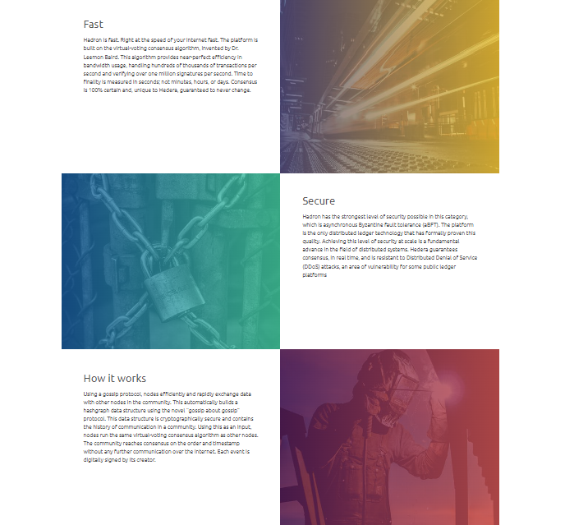

# About

Color: #f9f9f9, #464646

Use: section, h3, p, article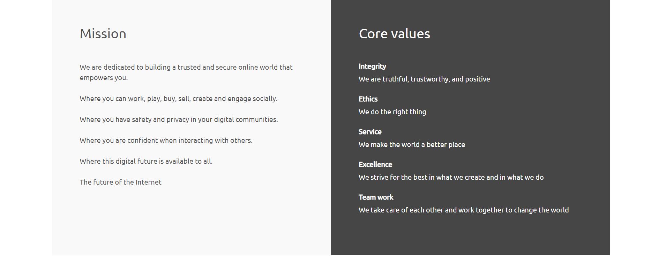

# Form

Color: #43cea2.

Use: section, h2, p, input, button

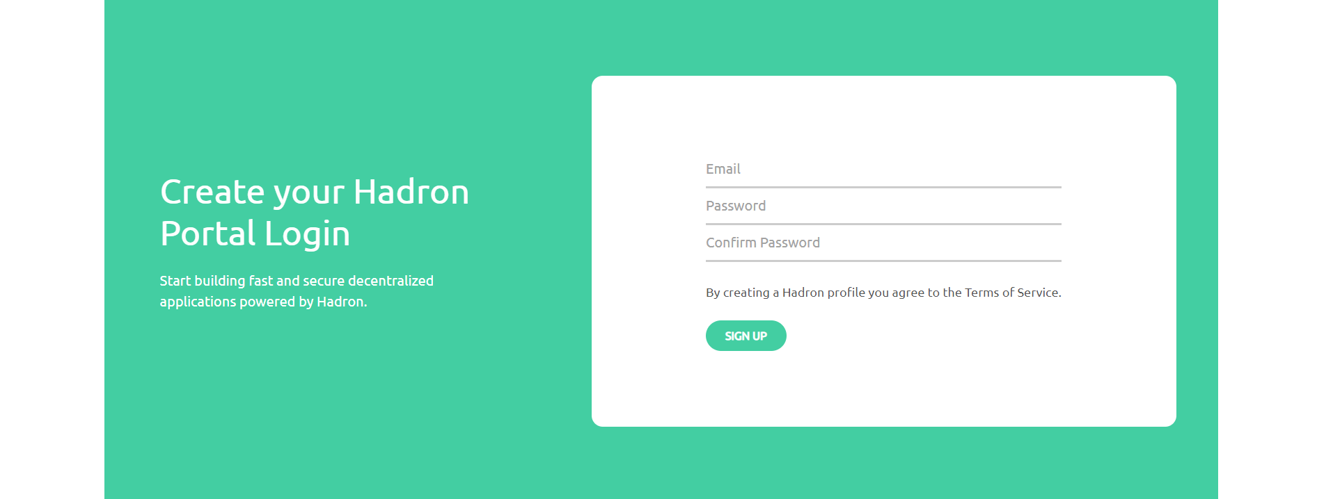

Hover:

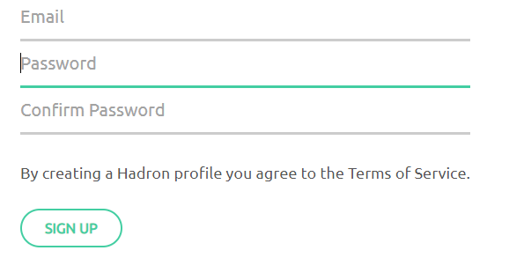

# Team

Color: #f83600, #43cea2, #8e2de2

Use: section, h3, figure, img, figcaption, h4, p



Hover:



# Footer

Color: gradient - #fac833, #544a7d, border - #a5a5a5

Use: footer, ul, li, a

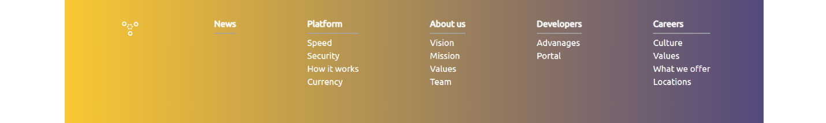

# 10.Responsive

Make the page responsive up to 800px.

Hints

Use - Media Queries